**Employee CRUD Operation**

Technical Design Document

***Objective:*** To perform CRUD operation for Employee table like adding an employee, deleting an employee and viewing all the employee. The UI appears as below to enter the fields like name , designation, address and phone.

***UI Screenshot:***

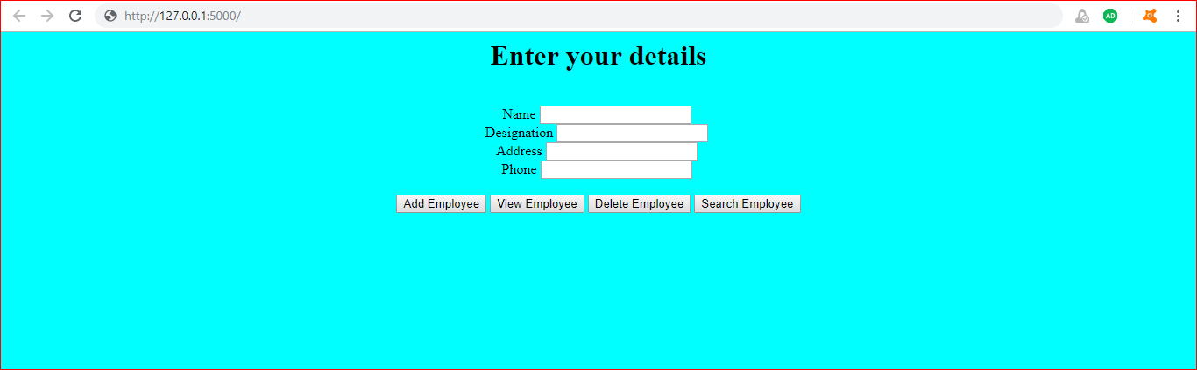

***Tools/Technology Used:***

The tools used for this application are Sublime(for writing Python scripts), cmd prompt(for running virtual environment and running flask), MySQL to connect to database and github to upload and share the code.

All the html files were placed in the templates folder.

***Activate virtual env:***

* venv\Scripts\activate

***Setting the FLASK_APP:***

* set FLASK_APP = app.py
* flask run

***Folder Structure:***

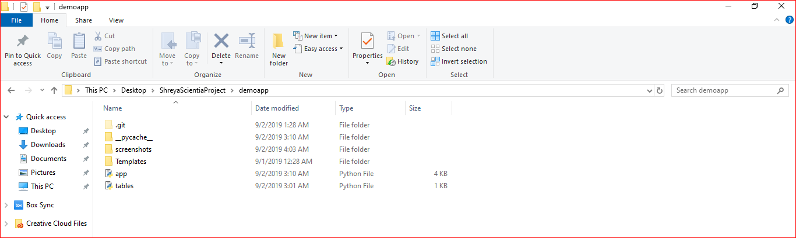

***Templates Folder:***

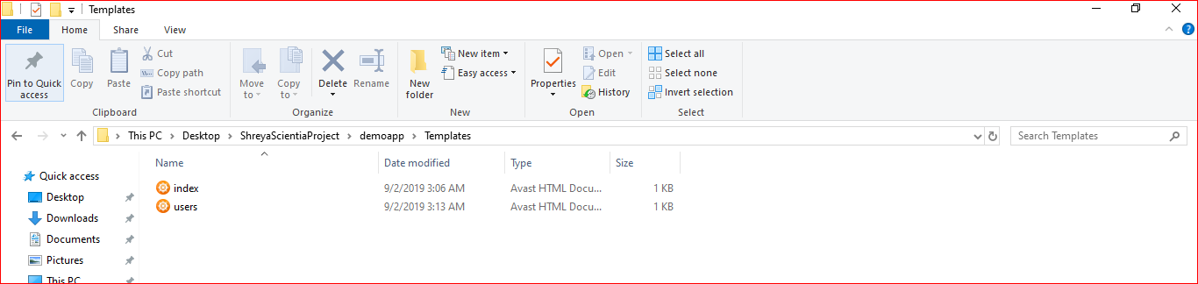

***Index.html***

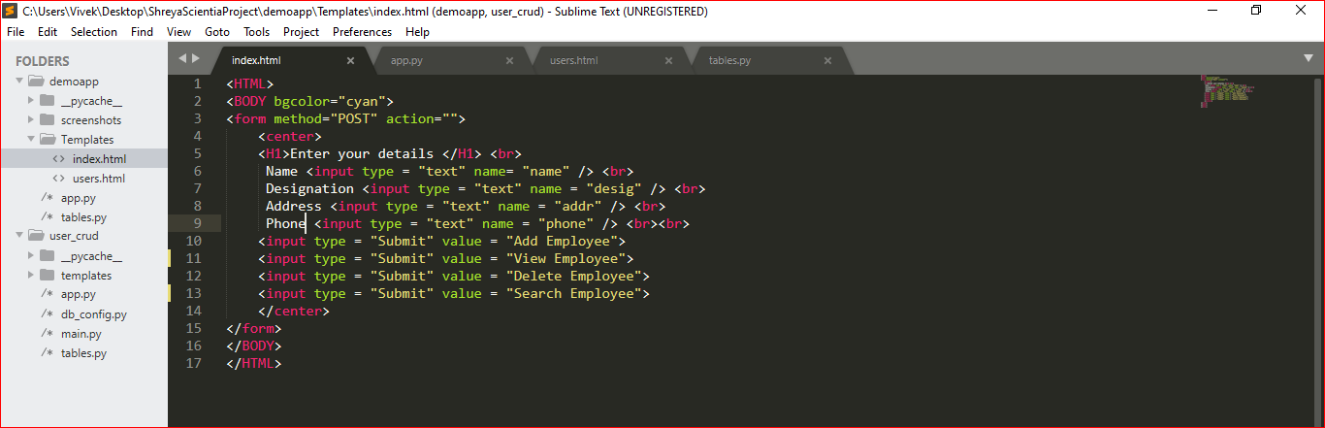

***Users.html***

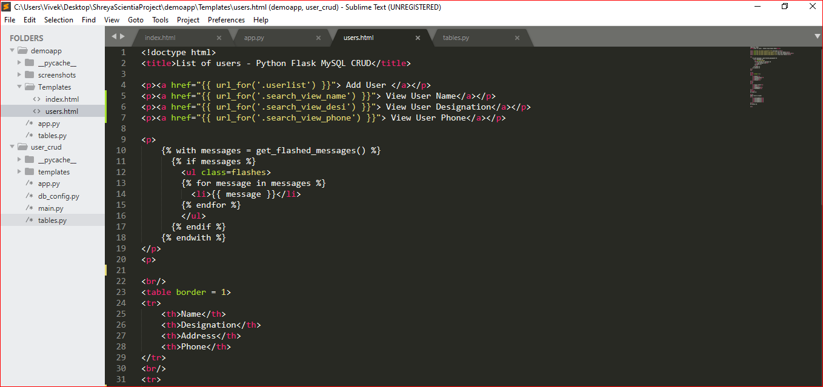

***Tables.py***

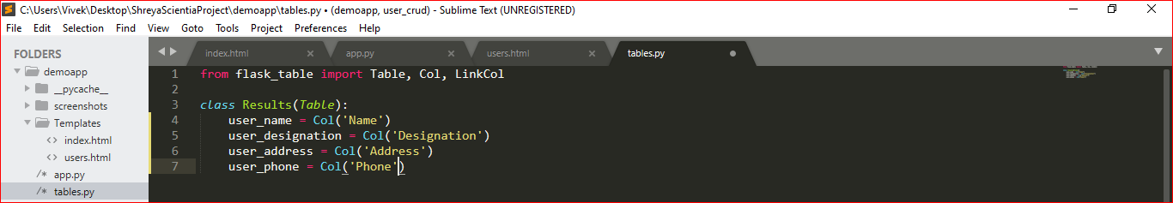

1. ***Add Employee Module***

This module will explain on how the new employee gets added to the database by entering name, designation, address and phone.

**Code Snippet:**

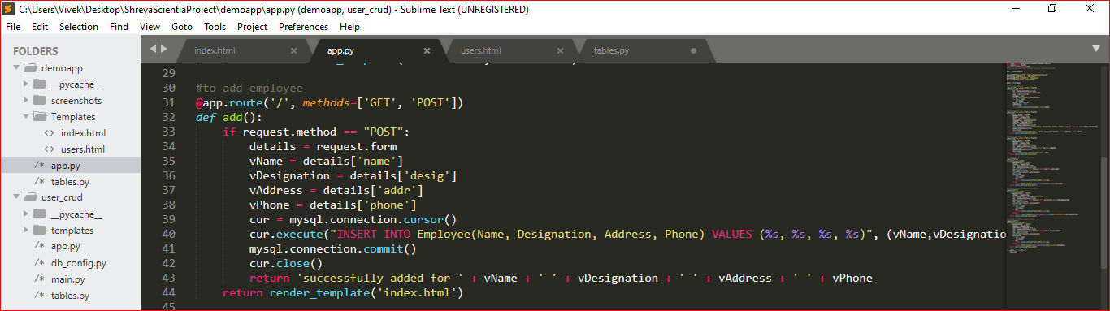

* 1. Before Adding Employee - Database

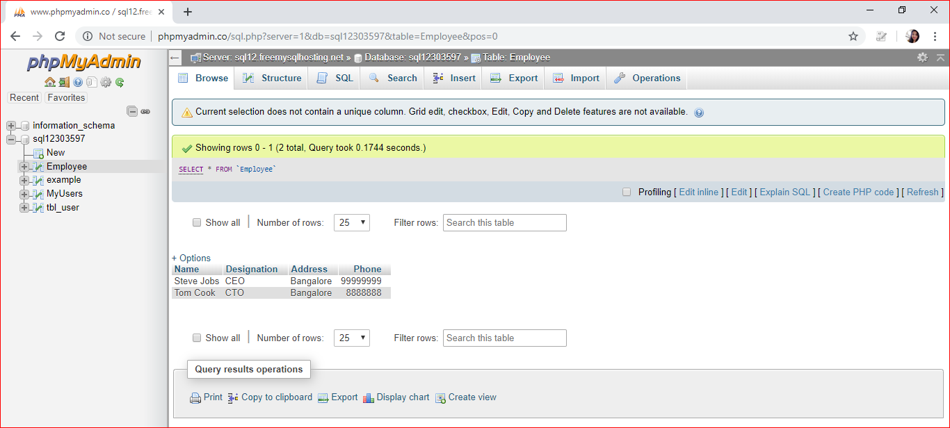

* 1. Before Adding Employee - UI

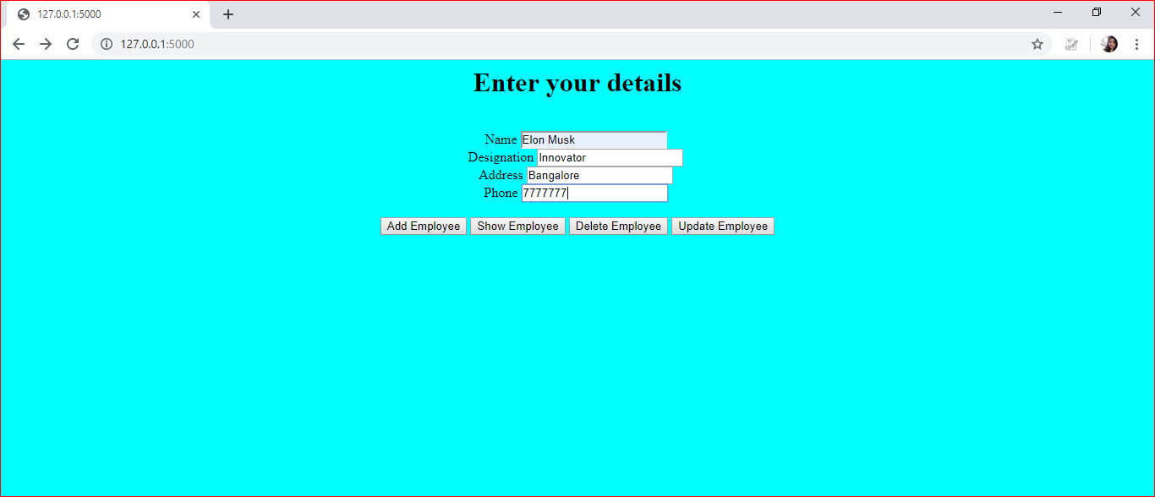

* 1. After Adding Employee - Database

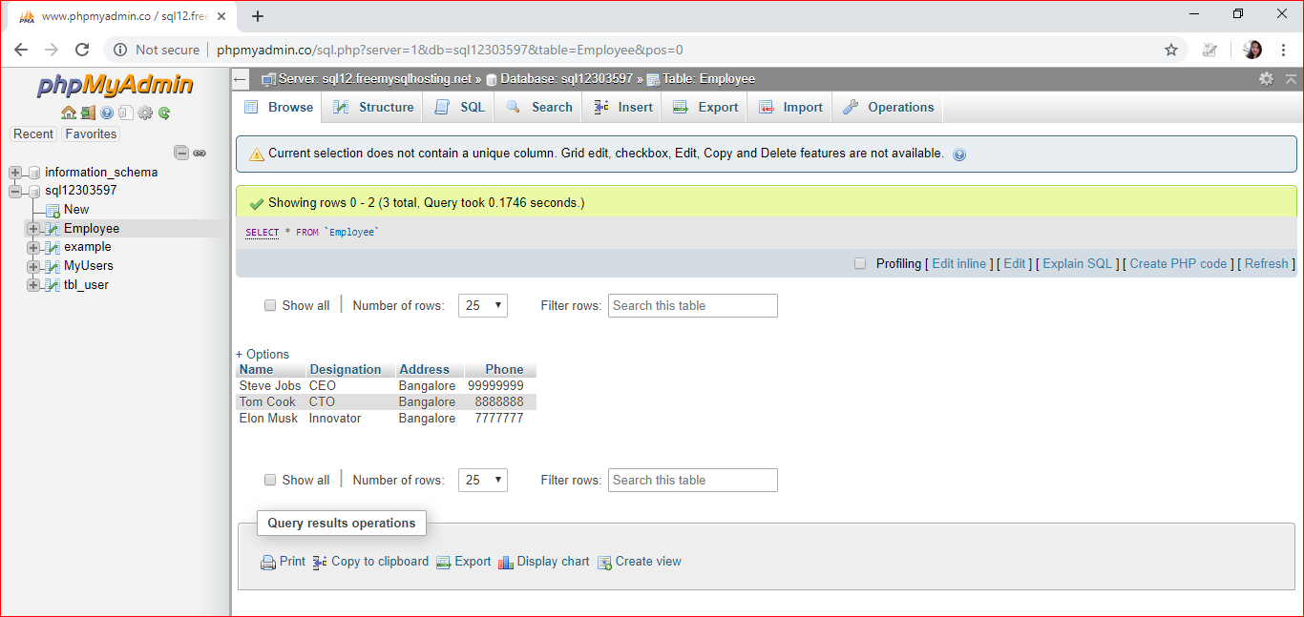

* 1. After Adding Employee - UI

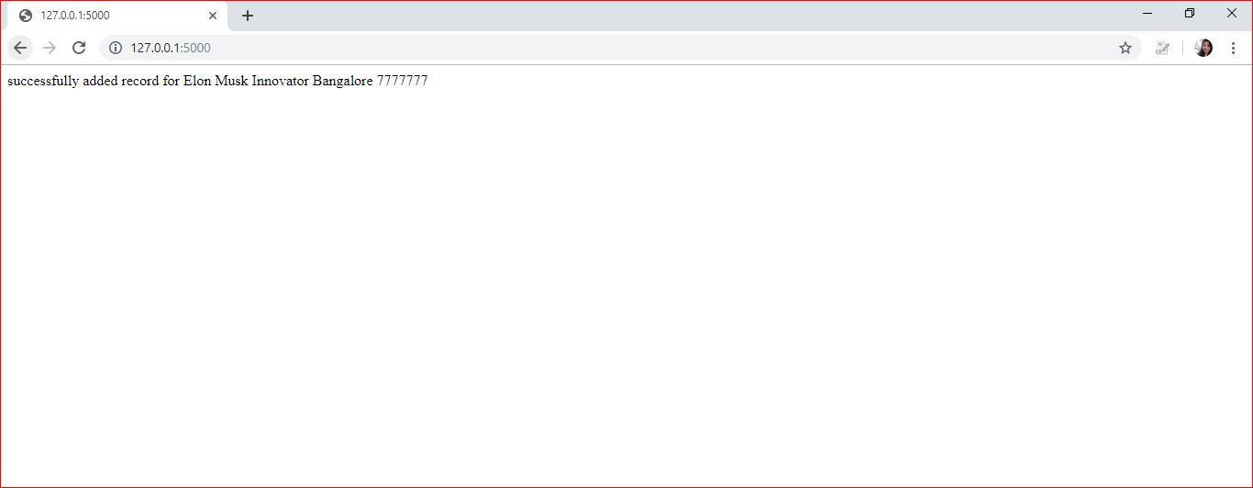

1. ***Delete Employee Module***

This module will explain on how to delete employee based on its name.

**Code Snippet:**

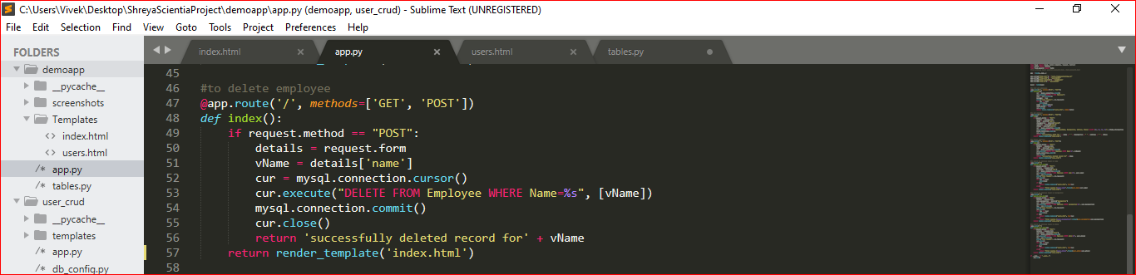

* 1. Before Deleting - Database

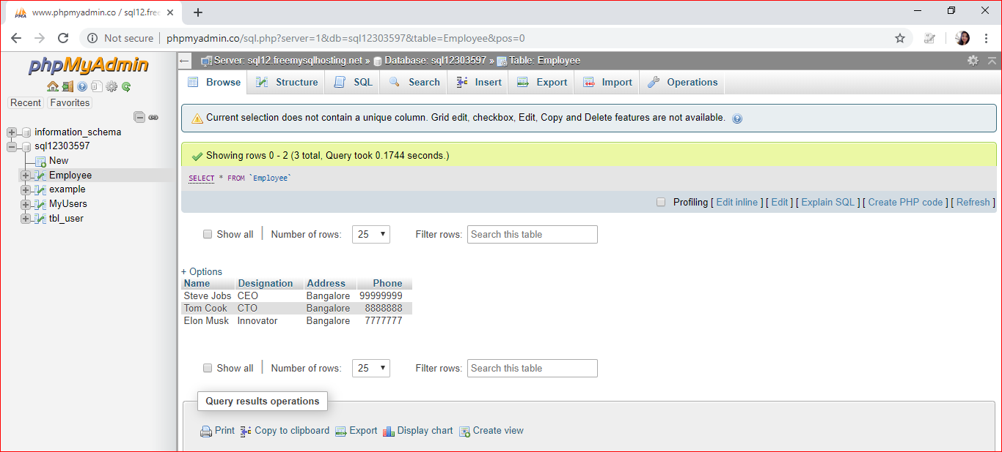

* 1. Enter the name to be deleted - UI

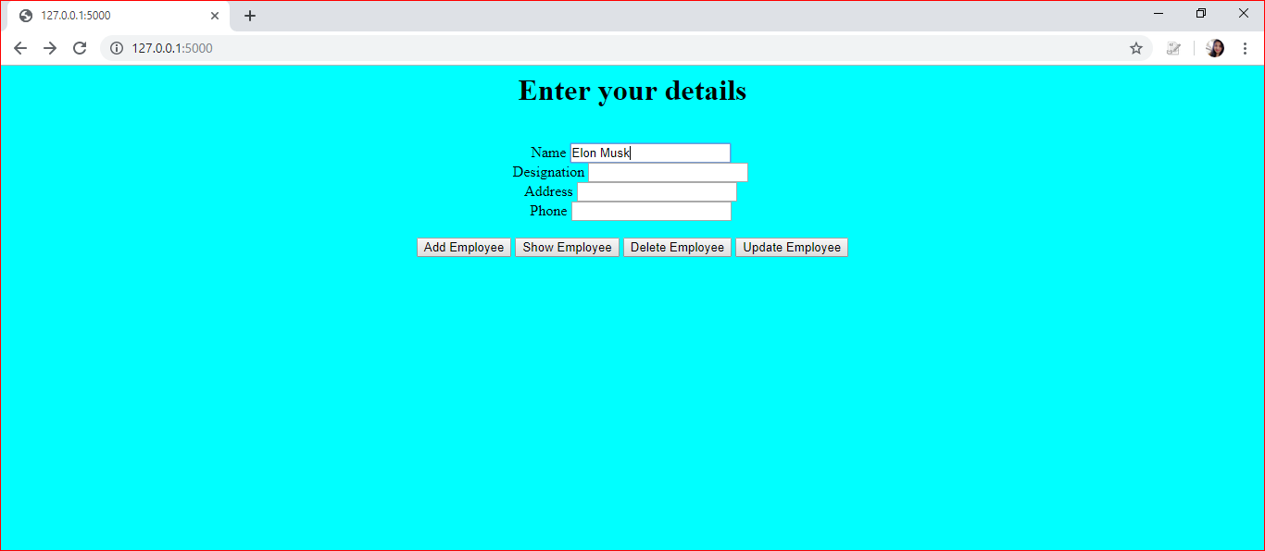

* 1. Record deleted - UI

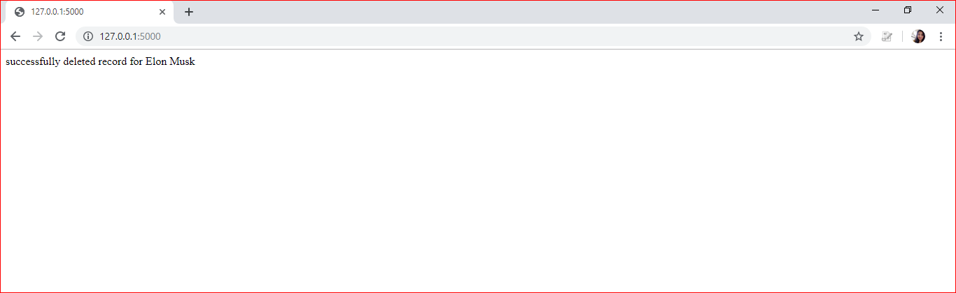

* 1. Record deleted - Database

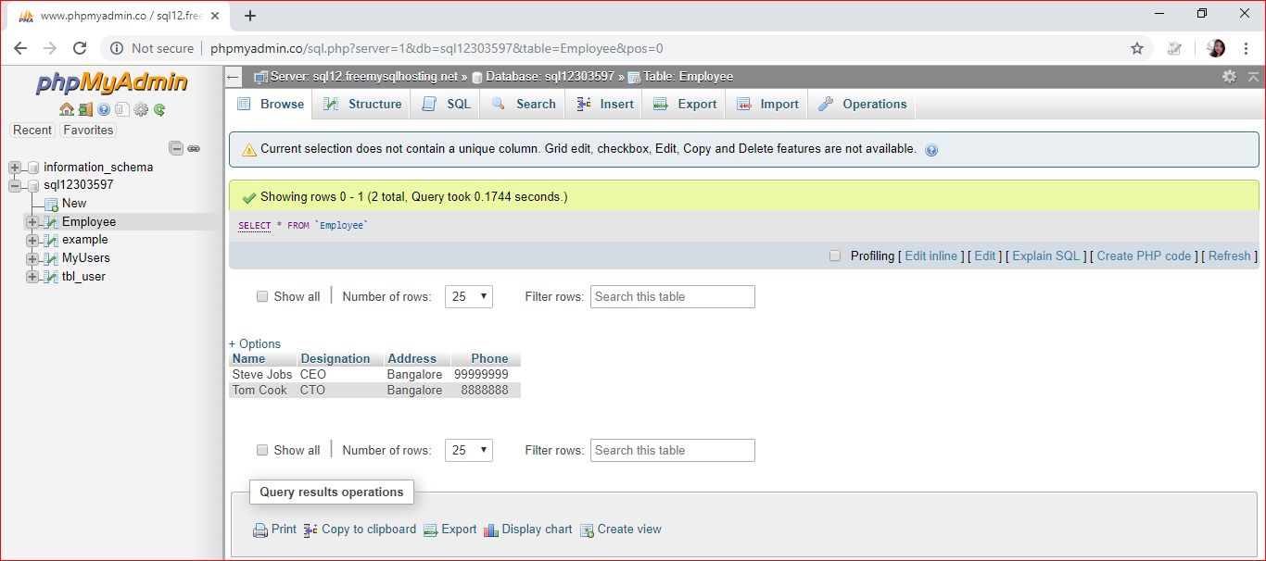

1. ***List All Employees Module***

This module will explain on how to list all the employees present in the database. It also explains the database configuration.

**Code Snippet:**

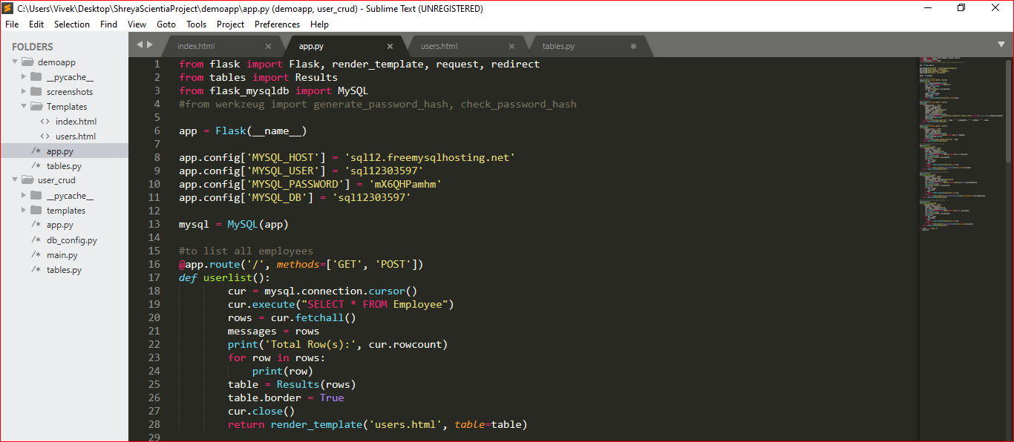

**Output Console Screenshot:**

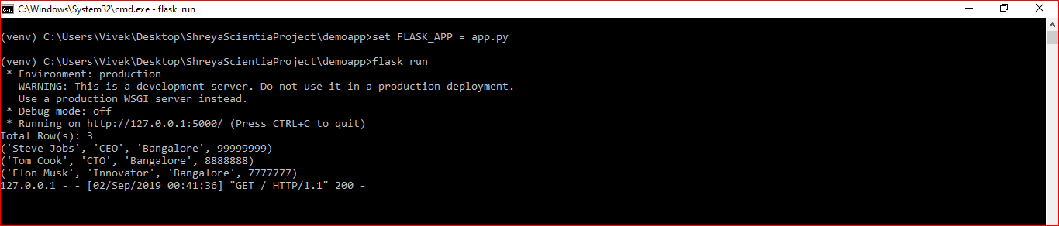

1. **Search Employee Screenshot:**

This module will explain on how to search for an employee present in the database based on name, designation and phone number.

**Code Snippet:**

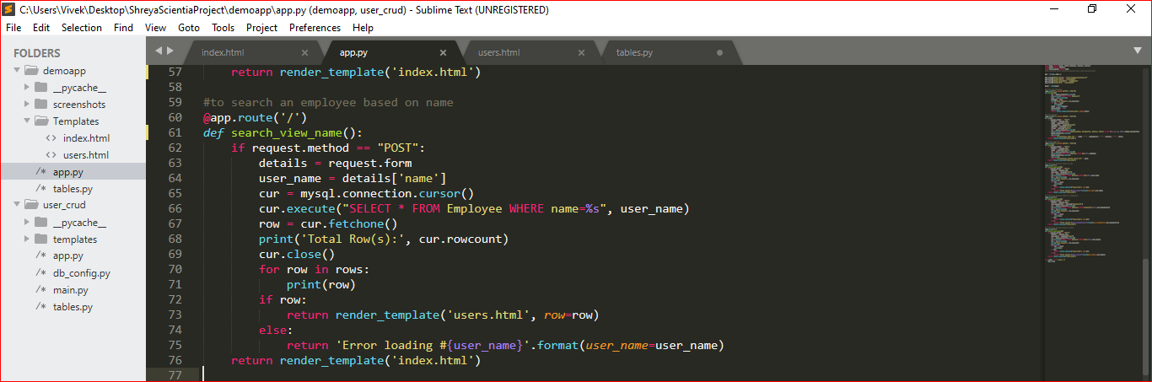

***Conclusion:***

This project overall performs the basic CRUD operations(except update) for Employee table.